## [**Use Cases**](https://docs.google.com/document/d/12XgfNrVNvVZUDHk7BYBtv-j7iTASqcnU_EvzfFDVBv4/edit) **(click for individual descriptions)**

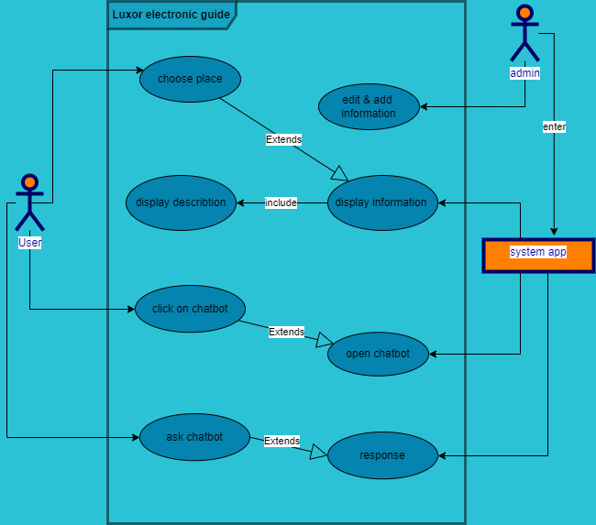

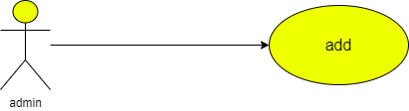

|  |  |  |
| --- | --- | --- |
| **Use case name** | Adding information | |
| **Unique ID** | 001 | |
| **Area** | Application | |
| **Actor(s)** | Admin | |
| **Description** | Admin adds data | |
| **Triggering Event** | Admin enters to database | |
| **Preconditions** | - The admin needs to login in to his account | |
| **Post conditions** | - Admin has successfully added data to application | |
| **Assumptions** | * Admin has application * A valid data | |
| **Steps Performed** | | **Information for Steps** |
| 1- Open application 2- Admin log in  3- admin enters database  4- Admin adds the new information in the system   1. Validation message | | Step 2: E-mail, Password |
| **Extensions (Alternative Flows)** | - If admin entered a non-valid data, a warning message should appear to him | |

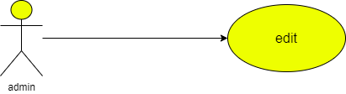

|  |  |  |
| --- | --- | --- |
| **Use case name** | Edit information | |
| **Unique ID** | 001 | |
| **Area** | Application | |
| **Actor(s)** | Admin | |
| **Description** | Admin edits data | |
| **Triggering Event** | Admin enters to database | |
| **Preconditions** | - The admin needs to login in to his account | |
| **Post conditions** | - Admin has successfully added data to application | |
| **Assumptions** | * Admin has application * A valid data | |
| **Steps Performed** | | **Information for Steps** |
| 1- Open application 2- Admin log in  3- admin enters database  4- Admin edits the information in the system   1. Validation message | | Step 2: E-mail, Password |
| **Extensions (Alternative Flows)** | - If admin entered a non-valid data, a warning message should appear to him | |

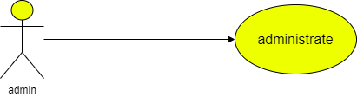

|  |  |  |
| --- | --- | --- |
| **Use case name** | Administrates information | |
| **Unique ID** | 001 | |
| **Area** | Application | |
| **Actor(s)** | Admin | |
| **Description** | Admin administrates the data about the app | |
| **Triggering Event** | Admin enters to database | |
| **Preconditions** | - The admin needs to login in to his account | |
| **Post conditions** | - Admin has successfully added data to application | |
| **Assumptions** | * Admin has application * A valid data | |
| **Steps Performed** | | **Information for Steps** |
| 1- Open application 2- Admin log in  3- admin enters database  4- Admin edits the information in the system   1. Validation message | | Step 2: E-mail, Password |
| **Extensions (Alternative Flows)** | - If admin entered a non-valid data, a warning message should appear to him | |

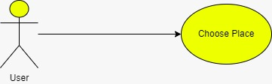

|  |  |  |
| --- | --- | --- |
| **Use case name** | * Choose place | |
| **Area** | * Application | |
| **Actor(s)** | * User | |
| **Description** | * The user select the desired place | |
| **Triggering Event** | * User selects the place on the screen | |
| **Preconditions** | - The user needs to be on the application | |
| **Post conditions** | - User has successfully entered the application | |
| **Assumptions** | * User has to use application | |
| **Steps Performed** | | **Information for Steps** |
| 1- Open application 2- User enters the application  3- User selects the icon | |  |
| **Extensions (Alternative Flows)** | - If user entered a non-valid data, a warning message should appear to him | |

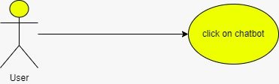

|  |  |  |
| --- | --- | --- |
| **Use case name** | * Click on chat bot | |
| **Area** | * Application | |
| **Actor(s)** | * User | |
| **Description** | * The user select the Chat bot | |
| **Triggering Event** | * User selects the chat bot icon | |
| **Preconditions** | - The user needs to be on the application | |
| **Post conditions** | - User has successfully entered the application | |
| **Assumptions** | * User has to use application | |
| **Steps Performed** | | **Information for Steps** |
| 1- Open application 2- User enters the application  3- User selects the chat bot icon | |  |
| **Extensions (Alternative Flows)** | - If user entered a non-valid data, a warning message should appear to him | |

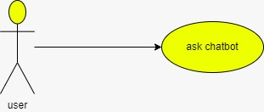

|  |  |  |
| --- | --- | --- |
| **Use case name** | * Ask chat bot | |
| **Area** | * Application | |
| **Actor(s)** | * User | |
| **Description** | * The user ask the Chat bot | |
| **Triggering Event** | * User selects the chat bot icon | |
| **Preconditions** | - The user needs to be on the application | |
| **Post conditions** | - User has successfully entered the application | |
| **Assumptions** | * User has to use application | |
| **Steps Performed** | | **Information for Steps** |
| 1- Open application 2- User enters the application  3- User selects the chat bot icon  4-User starts to ask it about what he needs to know | |  |
| **Extensions (Alternative Flows)** | - If user entered a non-valid data, a warning message should appear to him | |

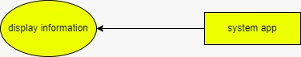

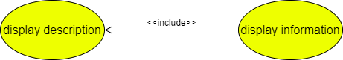

|  |  |  |
| --- | --- | --- |
| **Use case name** | * Display information | |
| **Area** | * Application | |
| **Actor(s)** | * System | |
| **Description** | * The data user selects shown on the application | |
| **Triggering Event** | * Non | |
| **Preconditions** | - The system need to be used | |
| **Post conditions** | - User has successfully entered the application and the application is on | |
| **Assumptions** | * The system is on | |
| **Steps Performed** | | **Information for Steps** |
| 1- Open application 2- User enters the application  3- User selects the desired information | |  |
| **Extensions (Alternative Flows)** | - If there is non-valid data, a warning message should appear to him | |

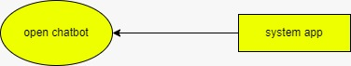

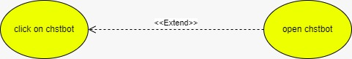

|  |  |  |
| --- | --- | --- |
| **Use case name** | * Open chat bot | |
| **Area** | * Application | |
| **Actor(s)** | * System | |
| **Description** | * The system calls chat bot | |
| **Triggering Event** | * Non | |
| **Preconditions** | - The system need to be used | |
| **Post conditions** | - User has successfully entered the application and the application is on | |
| **Assumptions** | * The system is on | |
| **Steps Performed** | | **Information for Steps** |
| 1- Open application 2- User enters the application  3- User selects the chat bot | |  |
| **Extensions (Alternative Flows)** | - If there is non-valid data, a warning message should appear to him | |



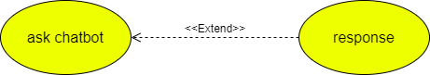

|  |  |  |
| --- | --- | --- |
| **Use case name** | * Response | |
| **Area** | * Application | |
| **Actor(s)** | * System | |
| **Description** | * Application response to user | |
| **Triggering Event** | * Non | |
| **Preconditions** | - The system need to be used | |
| **Post conditions** | - User has successfully entered the application and the application is on | |
| **Assumptions** | * The system is on | |
| **Steps Performed** | | **Information for Steps** |
| 1- Open application 2- User enters the application  3- User askes chat bot  4- System response to him | | Step1- Ask chat bot |
| **Extensions (Alternative Flows)** | - If there is non-valid data, a warning message should appear to him | |